|  |  |  |
| --- | --- | --- |
|  | **BAHRIA UNIVERSITY, (Karachi Campus)**  *Department of Software Engineering*  **Assignment 1 - Spring 2022** |  |



COURSE TITLE: Engineering Management COURSE CODE: **MGT-423**

Class: **BSE-IV (B)** Shift: **Morning**

Course Instructor: **Engr. Talha Bin Saeed** Time Allowed:  **3 Week**

Submission Date: **23/04/2022** Max. Marks:05

**[CLO1: 5 Marks]**

**QUESTION #01**

Discuss how engineers can play a significant role in driving innovations that will benefit customers and increase profits for the firm?

**QUESTION #02**

From your observations provide some examples of motivational theories that are being used  
by engineers in different firms?

**ANSWER#1**

In order to drive innovation, engineers need to be influential so that they can connect with employees at all levels in an organization. Innovation led by the engineers play a significant role in benefitting customers and increase company’s profits as both of them are interlinked with each other. Engineers are trained to innovate, but unfortunately, many have not learned the skills necessary to influence others and to develop ideas that increase profits. Engineers, then, need to know how to articulate their thoughts so that others will be inspired to build on them. They need to learn how to drive projects and ideas to create innovations that customers will value.

Following are seven reasons why technical professionals need leadership skills:

* Technical acumen alone is not influential. Technical gurus without leadership skills have limited influence.
* Leadership is not just for managers. Leading and managing require different skill sets. Some leadership experts might argue this point, but most agree that leadership has little to do with "management."
* Engineers lead projects. Even engineers who aren’t "project leads" provide a certain amount of direction, and they need to influence others to help get their work done.
* Engineers can guide less-experienced peers. Guidance is providing direction one of the three basic definitions of leadership (the other two are influence and authority).
* Engineers need to help their managers’ business succeed. You may not be inspired to help your manager be more successful as an individual, but you must be dedicated to help- ing your business achieve success. If not, find another job.
* Engineers can influence decision makers in their organizations. Engineers understand technology better than nontechnical managers, and they understand the details better than most technical managers.
* Everyone should be interested in building character. Leadership is mostly character and a little bit of skill. People listen to people who have integrity and who apply it well on the job.

Innovation and entrepreneurship are key drivers in today’s engineering world, and the push for sustainable products, services and technologies is needed now more than ever. From global corporations to small businesses, national governments to local governments, many are avidly searching for ways to come up with sustainable solutions to combat pressing environmental challenges. So, when it comes to innovation in engineering, it’s never been more critical. You’d be mistaken for thinking engineering is all about working with a rational and logical process with no room for creativity, when in fact engineering and innovation go hand in hand. Innovation is a great influence on the growth and survival of today’s engineering world, which is why it’s important higher education institutions are committed to the teaching of innovation and entrepreneurship.

**ANSWER#2**

Motivation is a state of mind, filled with energy and enthusiasm, which drives a person to work in a certain way to achieve desired goals. Motivation is a force that pushes people to work with a high level of commitment and focus, even if things are going against them. Motivation translates into a certain kind of human behaviour.  In short, motivation is the driving force behind human actions.

Depending upon the hierarchy of an organization and nature of the job, the usage of motivational theories varies for different engineers. Some common examples of such behaviors can be observed in government agencies, contractor organizations and private industry. Most of the government agencies’ decision making is highly influenced by the MOB (Management by objective) and Quality theory while the latter ones do not give much importance to them in their procedures. In the same way top level managers are more inclined towards using motivational theories as a mean to streamline their tasks as compared to the lower-level managers. Similarly, it is also noticed that high tech industries find it easier to integrate motivational theories in their objectives as compared to the low-tech industries. Motivation theory is a way of looking at the motivation of a person and how this influences their behavior, whether for personal or professional reasons. It's important to every aspect of society but is especially relevant to business and management. Motivation is the key to more profitable employees, as a motivated employee is more productive.

***Examples:***

### 1. Maslow’s Theory of Hierarchical Needs

Abraham Maslow postulated that a person will be motivated when all his needs are fulfilled. People do not work for security or money, but they work to contribute and to use their skills. He demonstrated this by creating a pyramid to show how people are motivated and mentioned that ONE CANNOT ASCEND TO THE NEXT LEVEL UNLESS LOWER-LEVEL NEEDS ARE FULFILLED. The lowest level needs in the pyramid are basic needs and unless these lower-level needs are satisfied people do not look at working toward satisfying the upper-level needs.

**Below is the hierarchy of needs:**

* **Physiological needs: are basic needs for survival such as air, sleep, food, water, clothing, sex, and shelter.**
* **Safety needs: Protection from threats, deprivation, and other dangers (e.g., health, secure employment, and property)**
* **Social (belongingness and love) needs: The need for association, affiliation, friendship, and so on.**
* **Self-esteem needs:  The need for respect and recognition.**
* **Self-actualization needs:  The opportunity for personal development, learning, and fun/creative/challenging work.  Self-actualization is the highest-level need to which a human being can aspire.**

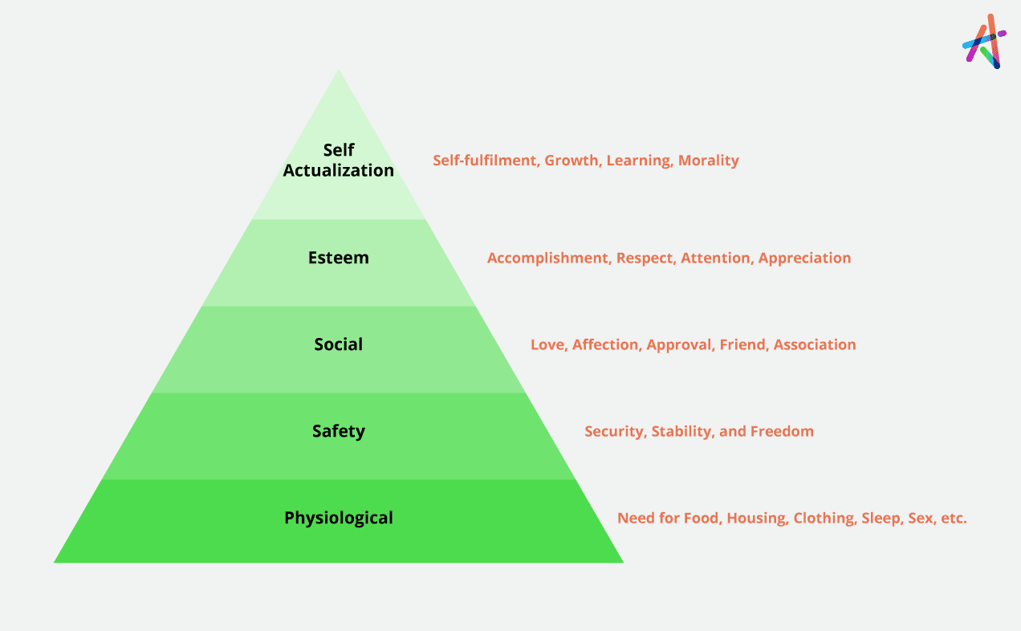

The leader will have to understand at what level the team members are currently, and seek out to help them to satisfy those specific needs and accordingly work to help fulfil those needs. This will help the team members perform better and move ahead with the project. Also, as their needs get fulfilled, the team members will start performing, till the time they start thinking of fulfilling the next upper level of need as mentioned in the pyramid.

### 2. Hertzberg’s two-factor Theory

Hertzberg classified the needs into two broad categories; namely hygiene factors and motivating factors:

* poor hygiene factors may destroy motivation but improving them under most circumstances will not improve [team motivation](https://www.knowledgehut.com/tutorials/project-management/team-motivation)
* hygiene factors only are not sufficient to motivate people, but motivator factors are also required

|  |  |  |
| --- | --- | --- |
| **Herzberg’s two-factor principles** | | |
| **Influenced by Hygiene Factors (Dis-satisfiers)** | **Improving motivator factors increases job satisfaction** | **Influenced by motivator factors (Satisfiers)** |
| * **Working condition** * **Coworker relations** * **Policies & rules** * **Supervisor quality** | **Improving the hygiene factors decreases job dissatisfaction** | * **Achievements** * **Recognition** * **Responsibility** * **Work itself** * **Personal growth** |

### 3. McClelland’s Theory of Needs

McClelland affirms that we all have three motivating drivers, which do not depend on our gender or age. One of these drives will be dominant in our behaviour. The dominant drive depends on our life experiences.

**The three motivators are:**

* **Achievement:**a need to accomplish and demonstrate own competence. People with a high need for achievement prefer tasks that provide for personal responsibility and results based on their own efforts.  They also prefer quick acknowledgment of their progress.
* **Affiliation:** a need for love, belonging and social acceptance. People with a high need for affiliation are motivated by being liked and accepted by others.  They tend to participate in social gatherings and may be uncomfortable with conflict.
* **Power:**a need for controlling own work or the work of others. People with a high need for power desire situations in which they exercise power and influence over others.  They aspire for positions with status and authority and tend to be more concerned about their level of influence than about effective work performance.

### 4. Vroom’s Theory of Expectancy

Vroom’s expectancy theory of motivation says that an individual’s motivation is affected by their expectations about the future. In his view, an individual’s motivation is affected by –

* **Expectancy:** Here the belief is that increased effort will lead to increased performance i.e., if I work harder then it will be better. This is affected by things such as:
  + Having the appropriate resources available (e.g., raw materials, time)
  + Having the appropriate [management skills](https://www.knowledgehut.com/tutorials/project-management/basic-management-skills) to do the job
  + Having the required support to get the job done (e.g., supervisor support, or correct information on the job)
* **Instrumentality:** Here the belief is that if you perform well, then the outcome will be a valuable one for me. i.e., if I do a good job, there is something in it for me. This is affected by things such as:
  + Clear understanding of the relationship between performance and outcomes – e.g., the rules of the reward ‘game’
  + Trust in the people who will take the decisions on who gets what outcome
  + Transparency in the process decides who gets what outcome
* **Valence:** is how much importance the individual places upon the expected outcome. For example, if someone is motivated by money, he or she might not value offers of additional time off.

**Motivation = V * I * E**

**The three elements are important when choosing one element over another, because they are clearly defined:**

* **E>P expectancy: our assessment of the probability that our efforts will lead to the required performance level.**
* **P>O expectancy: our assessment of the probability that our successful performance will lead to certain outcomes.**

### 5. McGregor’s Theory X and theory Y

Theory X and Theory Y were first explained by McGregor in his book, "The Human Side of Enterprise," and they refer to two styles of management – authoritarian (Theory X) and participative (Theory Y).

**Theory X:** Managers who accept this theory believe that if you feel that your team members dislike their work, have little motivation, need to be watched every minute and are incapable of being accountable for their work, avoid responsibility and avoid work whenever possible, then you are likely to use an authoritarian style of management. According to McGregor, this approach is very "hands-on" and usually involves micromanaging people's work to ensure that it gets done properly.

**Theory Y:** Managers who accept this theory believe that if people are willing to work without supervision, take pride in their work, see it as a challenge and want to achieve more, they can direct their own efforts, take ownership of their work and do it effectively by themselves. These managers use a decentralized, participative management style.

## ***Conclusion***

Motivation is the state of mind which pushes all human beings to perform to their highest potential, with good spirits and a positive attitude. The various motivation theories outlined above help us to understand what are the factors that drive motivation. It is a leader’s job to ensure that every individual in the team and the organization is motivated, and inspired to perform better than their best. This is neither quick nor easy, but in the long-term, the gains that are derived from happy employees far outweigh the time and effort spent in motivating them.